SecureTech Solutions Botswana - Website Planning & Documentation
1. Website Specifications
Objective:
The objective of the website is to create a professional online presence for SecureTech Solutions Botswana, a company that provides CCTV installation, access control systems, alarm systems and networking solutions.

Goals:
• Promote company services
• Increase brand awareness
• Generate customer leads
• Provide contact information and quotations
• Showcase completed projects

Target Audience:
The target audience includes homeowners, business owners, schools, offices and organisations in Botswana between ages 25–60. Most users have basic to intermediate internet knowledge and use smartphones and computers regularly.

Type of Website:
Business and service-based website focused on security solutions and customer engagement.

2. Information Design & Taxonomy
Site Map:
• Home
• About Us
• Services
• Projects
• Contact

Navigation Flow:
Users can move between all pages using the top navigation bar. All content is accessible within three clicks.

3. Page Template Design
The website uses responsive page templates with a hero section, service cards, project gallery and contact form. Bootstrap is used to improve layout responsiveness and spacing.

4. Technical Brief
Technologies Used
HTML5
HTML5 was used to create the structure of the website. It was used to build sections such as the navigation bar, headings, paragraphs, images, forms, and footer. HTML5 also helped create semantic and organized web pages.

CSS3
CSS3 was used to style the website and improve its appearance. It controlled colours, fonts, spacing, layouts, buttons, and responsiveness to make the website visually appealing and user-friendly.
JavaScript
JavaScript was used to add interactivity to the website. It helped with functions such as form validation, responsive navigation behaviour, and improving user experience.
Bootstrap 5
Bootstrap 5 was used to make the website responsive across different screen sizes. It provided ready-made classes for grids, navigation bars, buttons, forms, and layouts, making development faster and more professional.

Visual Studio Code
Visual Studio Code was used as the main code editor for writing and editing HTML, CSS, and JavaScript files. It provided extensions and tools that made coding easier and more efficient.
Git & GitHub
Git was used for version control to track changes made during development. GitHub was used to store the project repository online and manage the website files safely.
GitHub Pages
GitHub Pages was used to host and publish the website online, allowing users to access the live website through a web link.
Canva for Graphics
Canva was used to design logos, banners, and graphics used on the website to improve branding and visual appearance.

Testing Tools
Chrome Developer Tools
Chrome Developer Tools were used to test responsiveness, inspect elements, debug layout issues, and simulate mobile devices.
Mozilla Firefox
Firefox was used to test browser compatibility and ensure the website displayed correctly and functioned properly.
Microsoft Edge
Microsoft Edge was used to confirm that the website worked consistently across different browsers without errors.

5. Quality Assurance
Testing Included
Browser Compatibility Testing
The website was tested on multiple browsers to ensure that layouts, fonts, images, and features displayed correctly across all browsers.
Mobile Responsiveness Testing
The website was tested on different screen sizes such as smartphones and tablets to ensure that content adjusted properly and remained user-friendly.
Navigation Testing
All navigation links and menus were tested to ensure users could move between pages without broken links or errors.
Contact Form Validation
The contact form was tested to ensure users entered required information correctly before submitting the form.
Link Testing
All internal and external links were checked to confirm they directed users to the correct pages and resources.

Browsers Tested:
• Google Chrome
• Mozilla Firefox
• Microsoft Edge

6. Publishing & Promotion
The website is hosted using GitHub Pages.

GitHub Commands:
git init
git add .
git commit -m "Initial commit"
git push origin main

Website URL:
https://wakelema.github.io/cse25-411/

7. Future Developments / Recommendations
• Add online booking functionality
• Integrate live chat support
• Add customer accounts
• Improve SEO optimisation
• Add online payment integration

Low Fidelity Wireframe

Access Control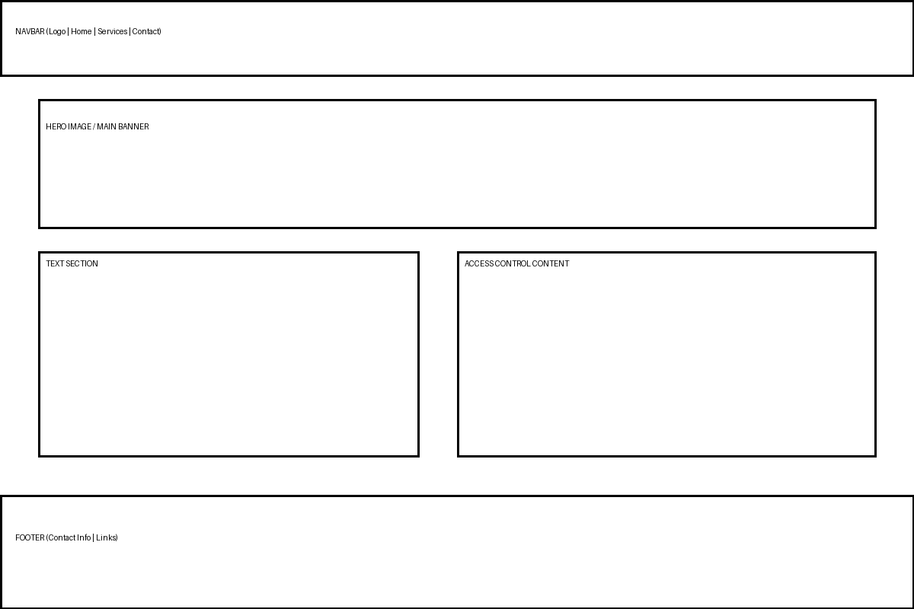
Alarm Systems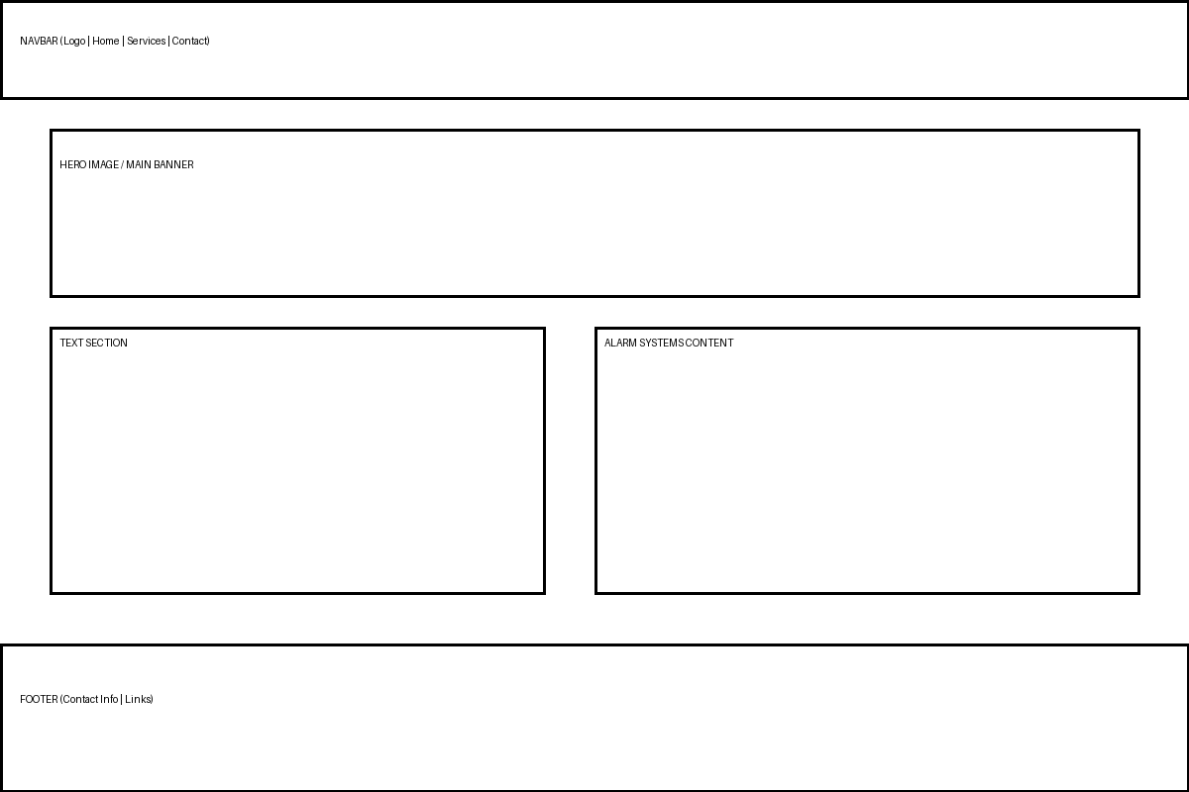
CCTV Installation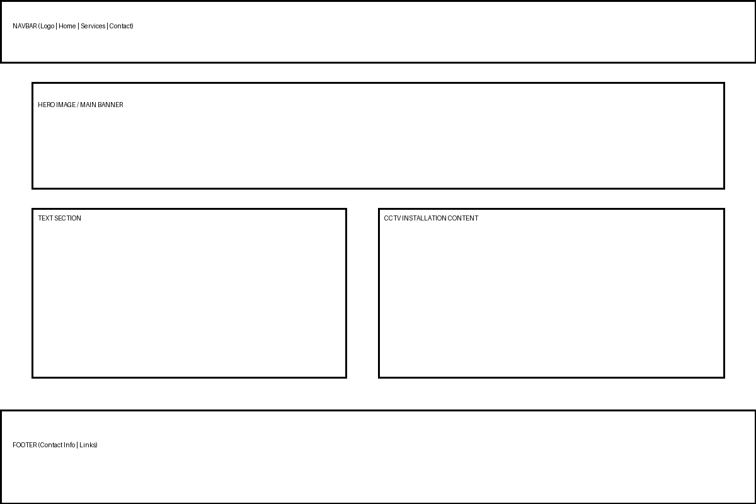
Home Page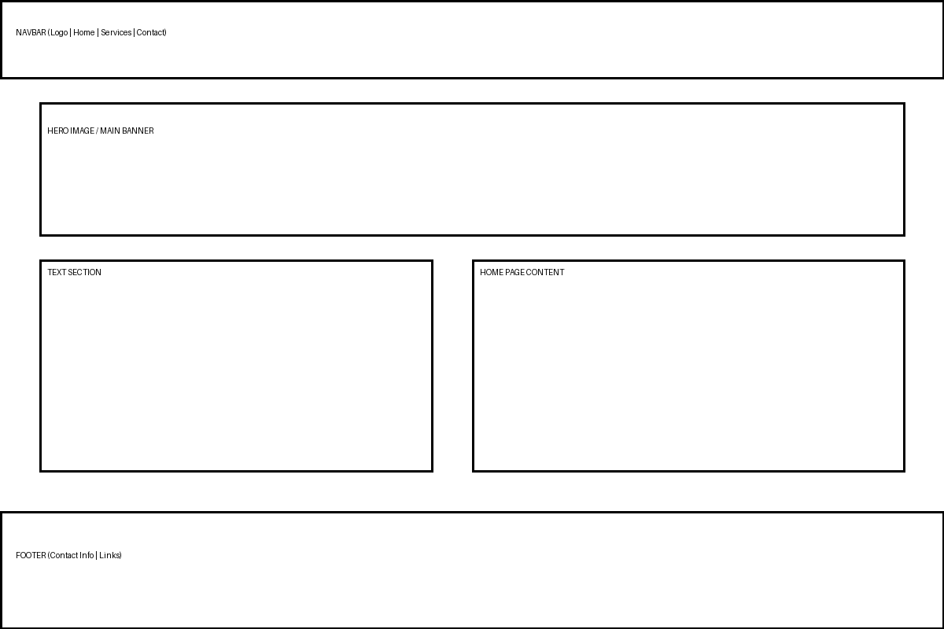
Maintanence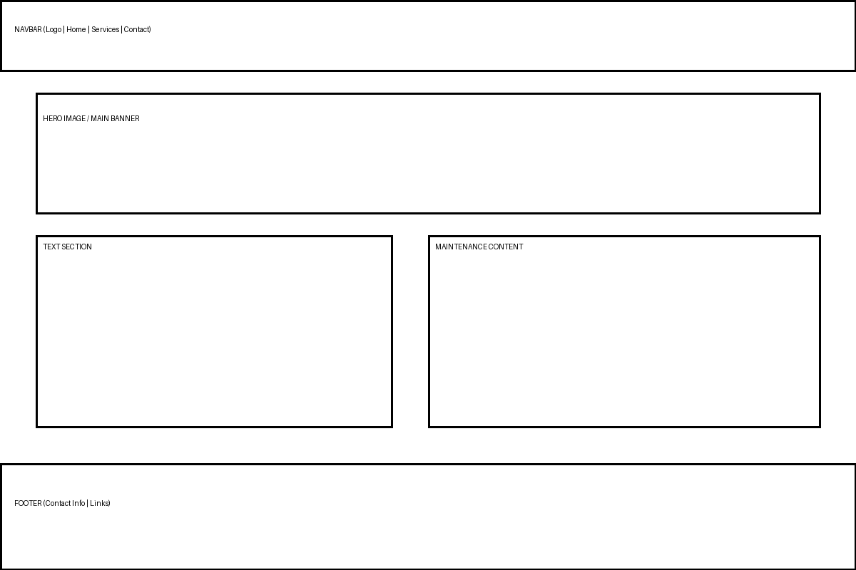
Services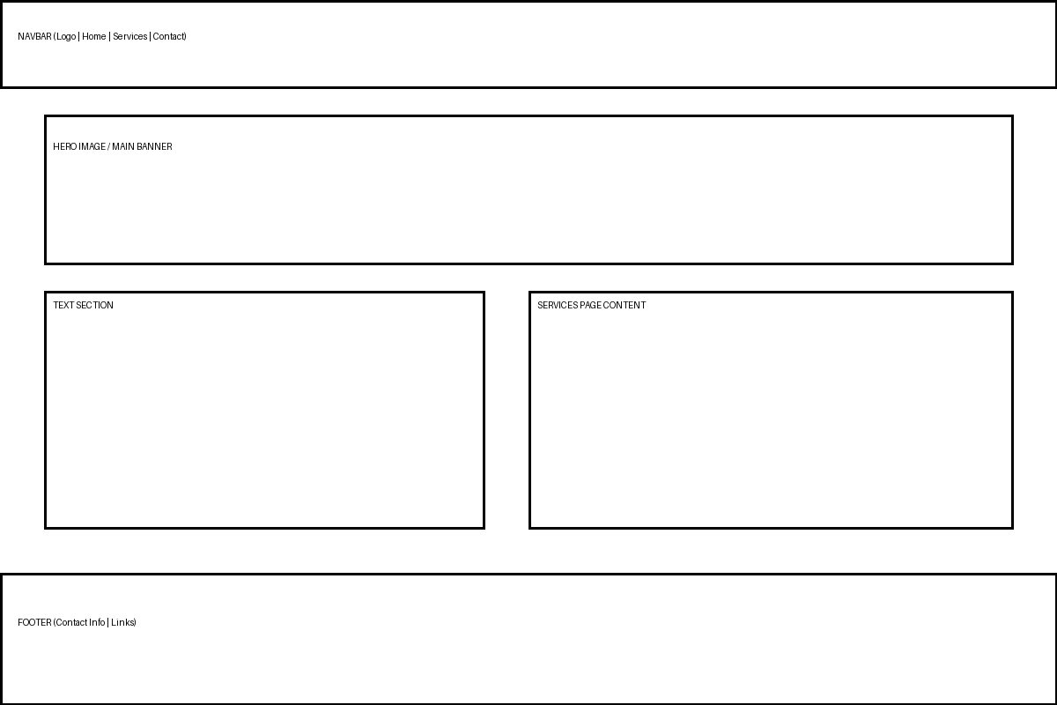

High Fidelity Wireframe

